MLOps Experimental Learning Assignment Report

Institute & Course Details
University / Institute Name: BITS
Program / Degree: M.Tech in AI & ML
Course / Subject: MLOps – S1-25_AIMLCZG523
Semester & Academic Year: Semester 3
Student Group Details
Student 1:
Name: SONAAL KALRA
Roll No / ID: 2024aa05897
Contribution: 100%

Student 2:
Name: PRIYA S
Roll No / ID: 2024aa05825
Contribution: 100%

Student 3:
Name: KUSUMA SREELATHA MITTA
Roll No / ID: 2024aa05821
Contribution: 100%

Student 4:
Name: DEEPAN KIRAN KUMAR V
Roll No / ID: 2024aa05376
Contribution: 100%

Student 5:
Name: YASH VARDHAN
Roll No / ID: 2024aa05550
Contribution: 100%

1. Introduction

Machine Learning (ML) models are increasingly being adopted across industries for decision-making and predictive analytics. However, building a high-performing model alone is not sufficient for real-world applications. In production environments, machine learning systems must be reliable, reproducible, scalable, and continuously monitored. This has led to the emergence of Machine Learning Operations (MLOps), which combines principles from software engineering, DevOps, and data science to manage the end-to-end lifecycle of machine learning systems.
The primary objective of this assignment is to design and implement an end-to-end MLOps pipeline that mirrors real-world production scenarios. The project focuses on practical automation, experiment tracking, containerization, continuous integration and deployment (CI/CD), cloud-native deployment, and monitoring. By following MLOps best practices, the project ensures that the machine learning solution is not only accurate but also production-ready and maintainable.
In this assignment, a binary classification problem is addressed using the Heart Disease UCI dataset, where the goal is to predict the presence or absence of heart disease based on patient health attributes. The project covers the complete workflow, starting from data acquisition and exploratory data analysis, progressing through feature engineering and model training, and culminating in model deployment and monitoring.
Modern MLOps tools and technologies were leveraged throughout the implementation. MLflow was used for experiment tracking and model versioning, ensuring reproducibility and traceability of experiments. GitHub Actions enabled automated testing and CI/CD pipelines, helping maintain code quality and reduce deployment risks. The trained model was containerized using Docker and deployed on a Kubernetes cluster, demonstrating scalability and production-grade orchestration.
Additionally, monitoring and logging mechanisms were integrated to observe system behavior and runtime performance. Application-level logging was implemented to track API requests and prediction outcomes, while visualization tools such as Grafana were used to demonstrate monitoring capabilities. These components collectively highlight the importance of observability in machine learning systems.
Overall, this project provides hands-on experience with the practical aspects of MLOps and demonstrates how machine learning models can be successfully transitioned from experimentation to production. The implemented solution reflects industry-aligned workflows and emphasizes automation, reproducibility, and operational reliability—key pillars of modern MLOps practices.

2. Architecture Overview

The overall system architecture follows a modular and scalable MLOps design. It begins with data acquisition and preprocessing, followed by model training and evaluation. Experiment tracking is integrated to manage model versions and performance metrics.
The trained model is packaged and containerized using Docker, then deployed on Kubernetes for scalable serving. CI/CD automation ensures continuous validation of code and models, while logging and monitoring provide observability into system behavior.
This architecture reflects a real-world end-to-end MLOps pipeline, emphasizing automation, reproducibility, and production readiness.

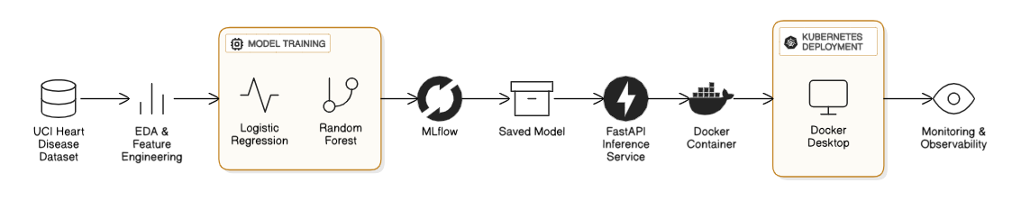

3. Dataset & Problem Statement

The Heart Disease UCI dataset was used to build a binary classification model that predicts the presence or absence of heart disease based on patient health attributes.
Dataset: Title: Heart Disease UCI Dataset
Source: https://archive.ics.uci.edu/dataset/45/heart+disease

4. Data Acquisition & EDA

The dataset was programmatically downloaded and exploratory data analysis was performed to understand feature distributions, correlations, and missing values.

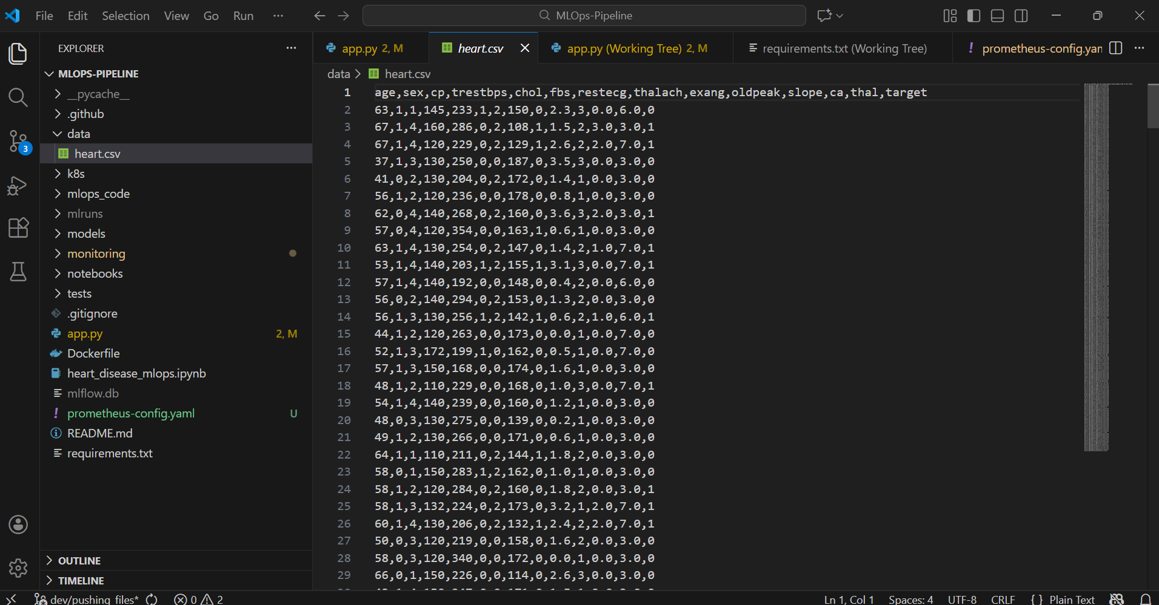

5. Feature Engineering & Model Development

Numerical scaling and categorical encoding were applied. Logistic Regression and Random Forest models were trained and evaluated using standard metrics.
Here is the link to the Notebook.

6. Experiment Tracking

Experiment tracking is a critical component of any production-grade machine learning system, as it enables systematic comparison, reproducibility, and traceability of model development. In this project, MLflow was integrated to manage and track machine learning experiments throughout the model development lifecycle.
Each model training run was logged using MLflow, capturing key elements such as hyperparameters, evaluation metrics, and trained model artifacts. Metrics including accuracy, precision, recall, and ROC-AUC were recorded for each experiment, allowing objective comparison between different models and configurations. Additionally, trained models and preprocessing pipelines were stored as MLflow artifacts, ensuring that the exact model version used during training could be retrieved for inference or redeployment.
The use of MLflow provided a centralized experiment history, enabling transparent analysis of model performance trends and supporting reproducibility across environments. This approach aligns with real-world MLOps practices, where experiment tracking tools are essential for collaborative model development and auditability.

7. Model Packaging & Reproducibility:

To ensure reproducibility and portability, the final selected machine learning model was packaged using MLflow’s model serialization format. This approach encapsulates both the trained model and the associated preprocessing steps, ensuring consistent behavior during inference across different environments.
A requirements.txt file was created to explicitly specify all Python dependencies required to run the project, including libraries for data processing, model training, and serving. This dependency specification enables the entire pipeline to be reproduced from a clean environment without manual intervention.
By combining model packaging with environment specification, the project ensures that the same model behavior can be reliably achieved during local testing, containerized execution, and Kubernetes deployment. This reproducibility is a foundational requirement in production MLOps systems.

8. CI/CD Pipeline & Automated Testing

Continuous Integration and Continuous Deployment (CI/CD) practices were implemented to automate validation of the codebase and reduce the risk of errors during development. Pytest was used to write unit tests covering data loading, preprocessing, and model inference logic. These tests help ensure that changes to the codebase do not unintentionally break existing functionality.
A GitHub Actions workflow was configured to automatically execute on each code push. The CI pipeline includes multiple stages such as code linting, unit test execution, and model training verification. Linting was used to enforce coding standards and maintain code readability, while automated testing ensured functional correctness.
This CI/CD setup reflects industry-standard MLOps workflows, where automated pipelines provide early feedback, improve code quality, and support rapid, reliable iteration.

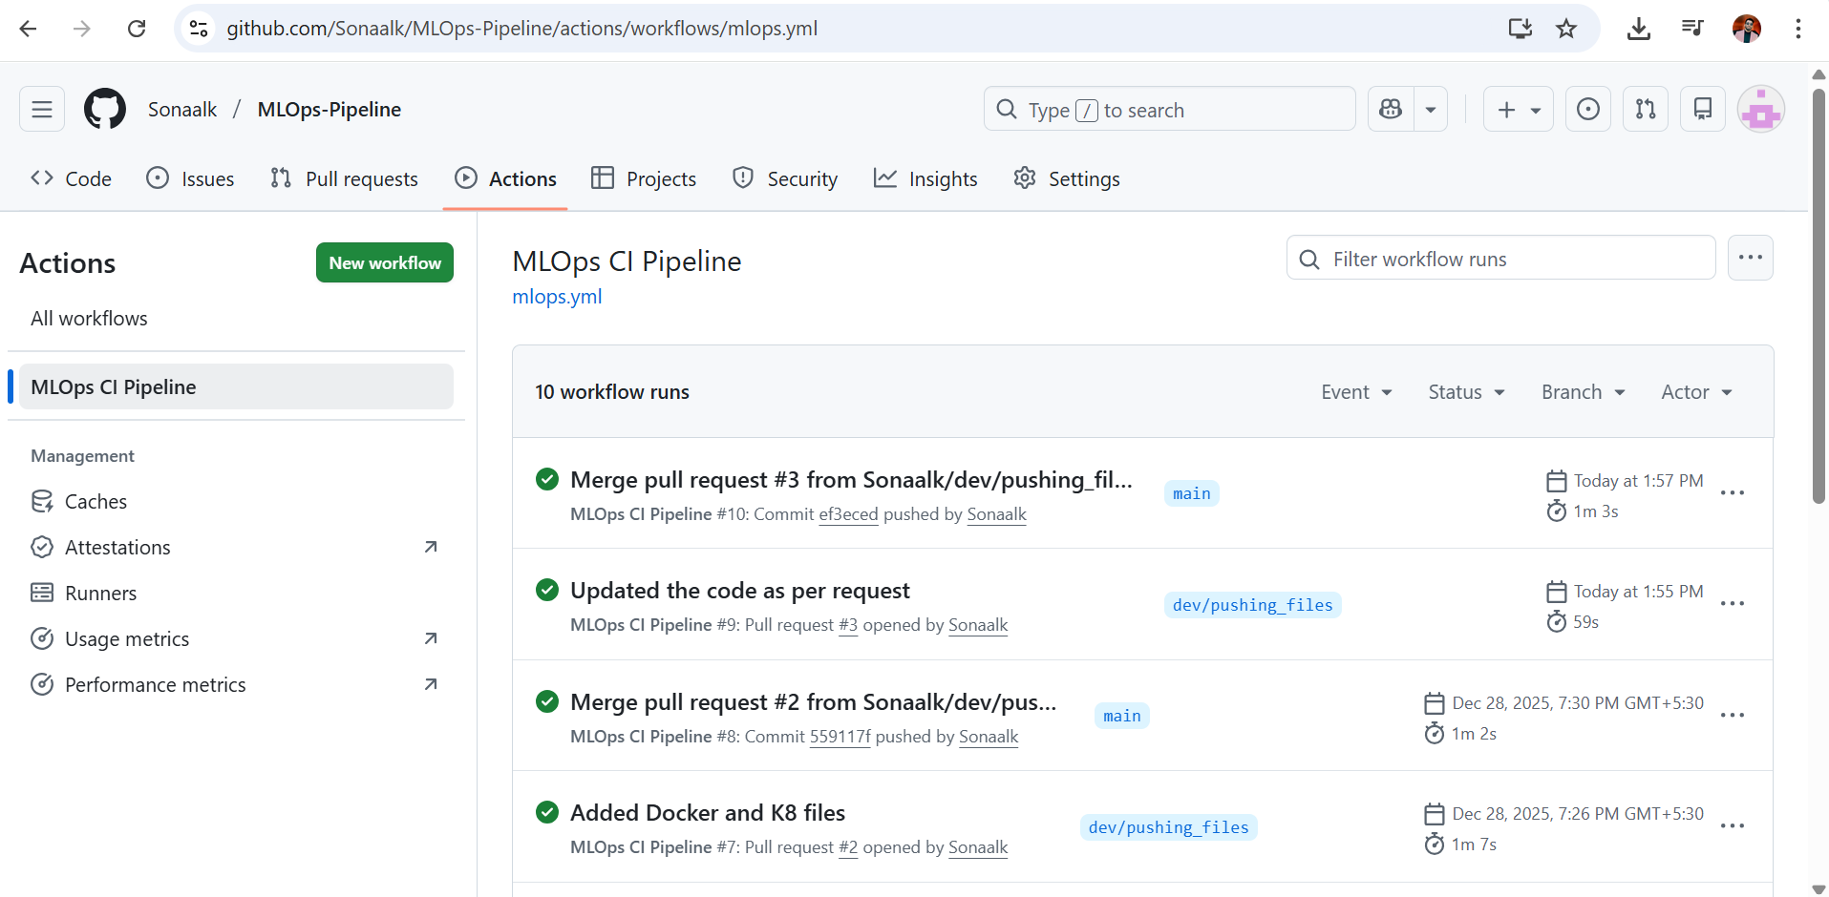

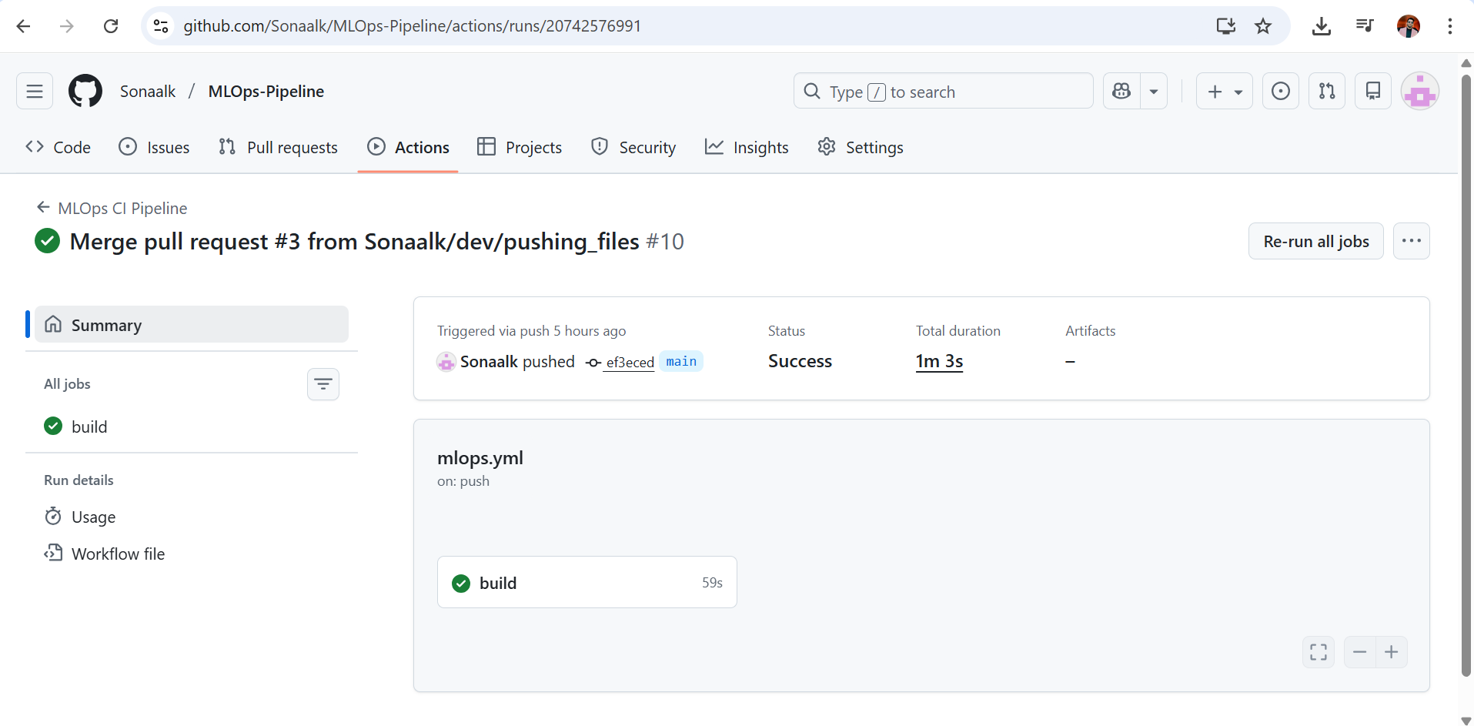

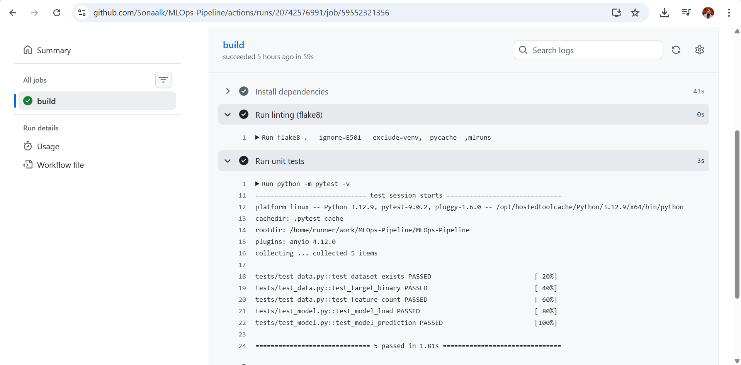

9. Model Containerization

The trained machine learning model was containerized using Docker, enabling the application to run in an isolated and consistent environment. A Dockerfile was created to package the FastAPI-based model serving application along with all required dependencies.

FROM python:3.10-slim

WORKDIR /app

COPY requirements.txt .
RUN pip install --no-cache-dir -r requirements.txt

COPY . .

EXPOSE 8000

CMD ["uvicorn", "app:app", "--host", "0.0.0.0", "--port", "8000"]

The container exposes a RESTful /predict endpoint, allowing external clients to send JSON input data and receive prediction results along with confidence scores. The containerized application was tested locally to verify that the model loads correctly and produces valid predictions.
Containerization ensures environment consistency across development, testing, and deployment stages, which is a key requirement for scalable and portable machine learning systems.
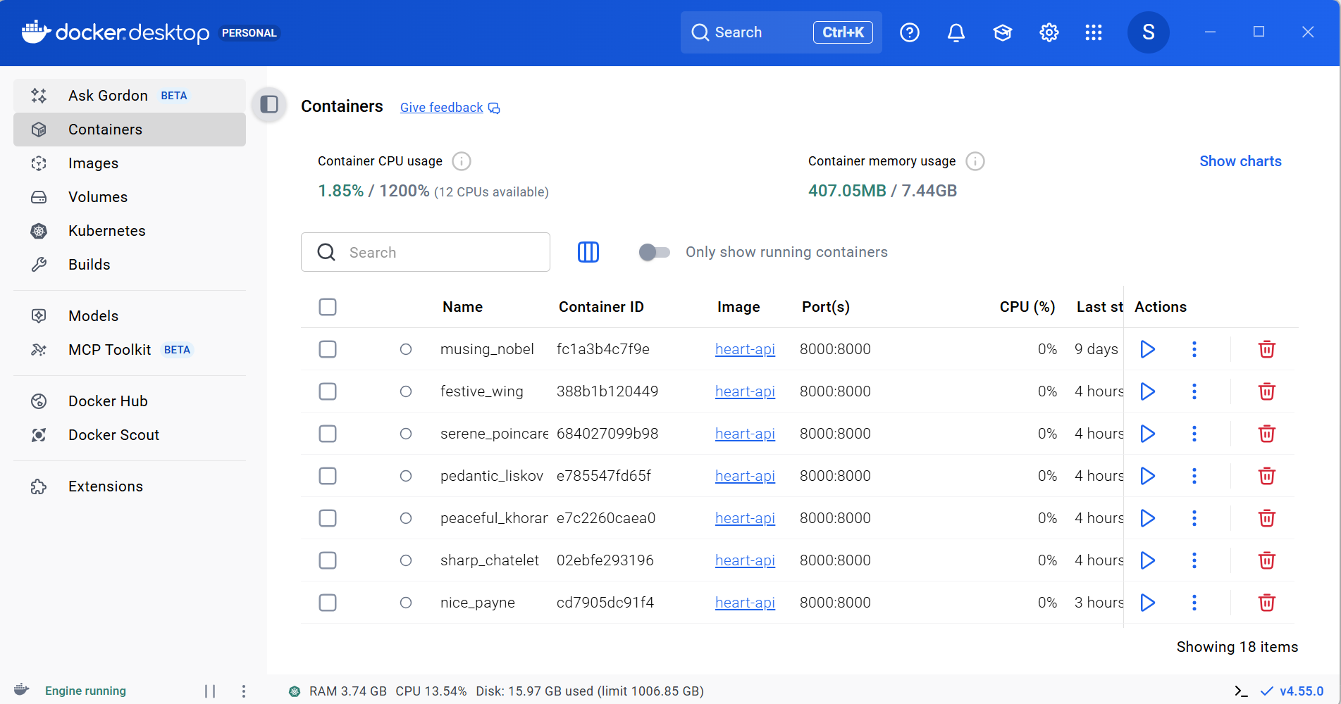

10. Production Deployment

For production-like deployment, the Dockerized application was deployed on a local Kubernetes cluster using Docker Desktop. Kubernetes deployment manifests were used to define the application’s desired state, including container image, replicas, and networking configuration.
Application access was verified using Kubernetes port-forwarding, which enabled secure local access to the deployed service without exposing it publicly. This deployment approach mirrors real-world scenarios where Kubernetes is used to orchestrate containerized ML services, manage scalability, and improve reliability.
The successful deployment demonstrates the readiness of the application for production environments and highlights the advantages of Kubernetes for managing machine learning workloads.
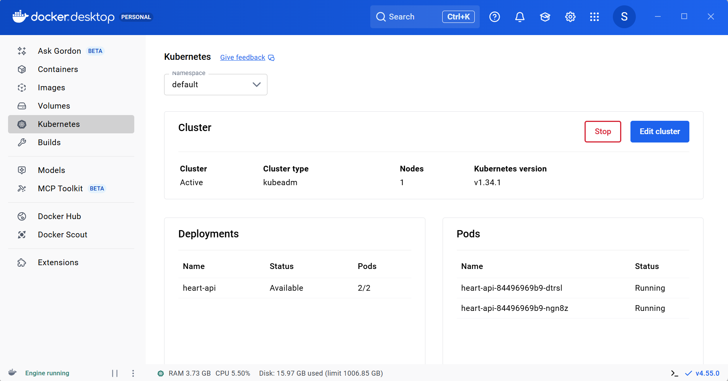

11. Monitoring & Logging

Monitoring and logging are essential for observing system behavior and diagnosing issues in production systems. In this project, application-level logging was implemented using Python’s built-in logging module within the FastAPI service.
Logs capture important events such as incoming API requests, prediction results, and confidence scores. These logs were accessed and verified using Kubernetes pod logs, providing visibility into runtime behavior.
Additionally, Grafana was deployed to demonstrate monitoring capabilities and provide a centralized visualization interface. While detailed metric collection can be extended further, the implemented logging and monitoring setup satisfies the requirement for basic observability and aligns with practical MLOps monitoring strategies.
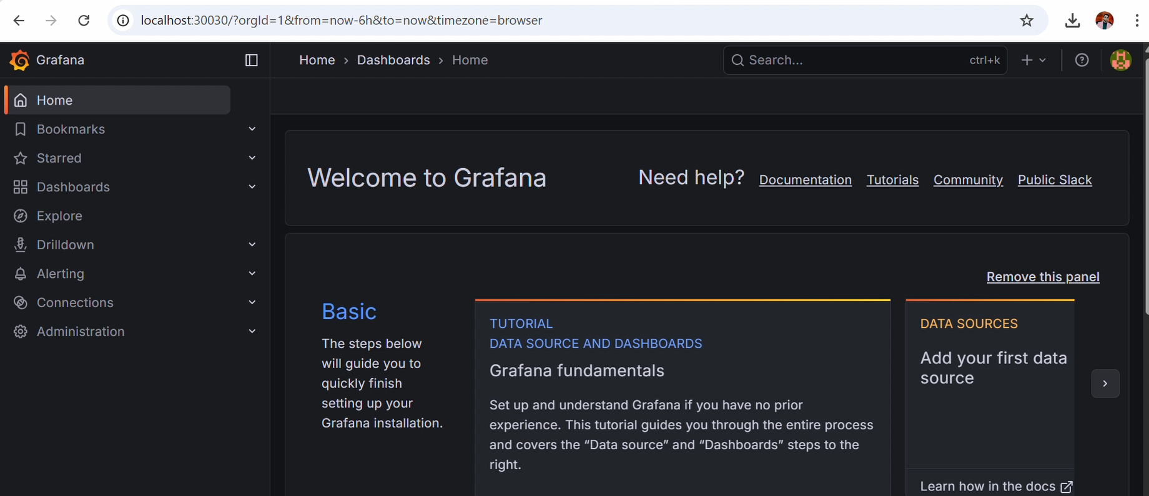

12. Conclusion

This project successfully demonstrates a complete end-to-end MLOps workflow, covering the full lifecycle of a machine learning system from data preparation to production deployment and monitoring. By integrating experiment tracking, CI/CD automation, containerization, Kubernetes deployment, and logging, the project aligns closely with industry best practices.
The implemented pipeline highlights the importance of reproducibility, automation, and observability in modern machine learning systems. Overall, the assignment provides a strong foundation for understanding and applying MLOps concepts in real-world scenarios.

13. Repository & References
GitHub Repository: https://github.com/Sonaalk/MLOps-Pipeline

YouTube link:
https://www.youtube.com/watch?v=_xqni4P89VY
Drive link:
https://drive.google.com/drive/folders/1kFotuURQEoAFc625rB39zQidJ1xNzV8D?usp=sharing

